Technical document

Note: I generally don’t write pseudocode code, I prefer to describe the problem and the solution in plain English. I wrote pseudocode code for this assignment as it was required but it may not be the best

**Components:**

The project is broken down into 3 main components with further sub components

1. Desktop program
   1. PDF reading and display
   2. Arduino communication
   3. GUI layer
2. Receiver program
   1. Receiving and processing information
   2. Sending information to computer
   3. Sending information to other Arduino devices
3. Device program
   1. GPS communicator and translator
   2. Information passing protocols
   3. Power consumption manager

**External libraries**

The RXTX library for serial communication with the Arduino. It is an open source library with a standard MIT license.

The PDF Reader Library used for reading PDF files and displaying those PDFs. MIT license

**Break down of components**

Desktop Program

*Reading and display:*

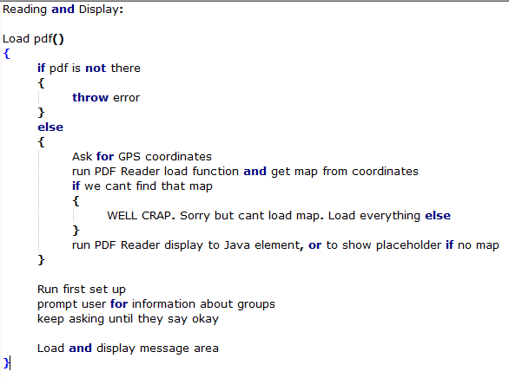

*Arduino Communication*

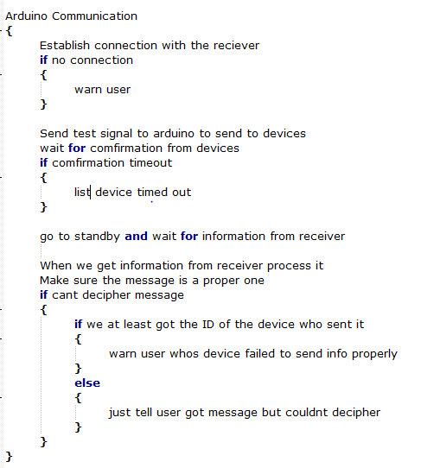

*GUI layer*

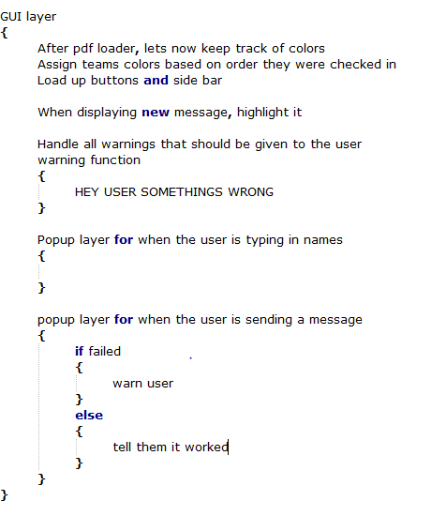

Receiver

*Receive and process info*

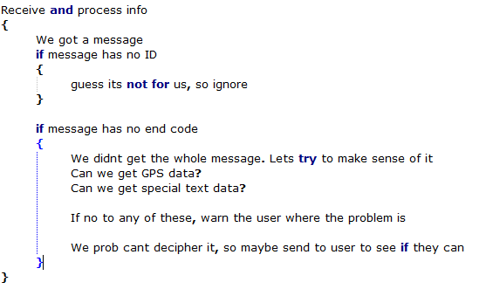

*Send info to computer*

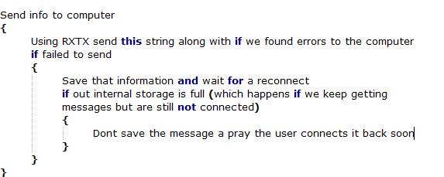

*Send info to other Arduino devices*

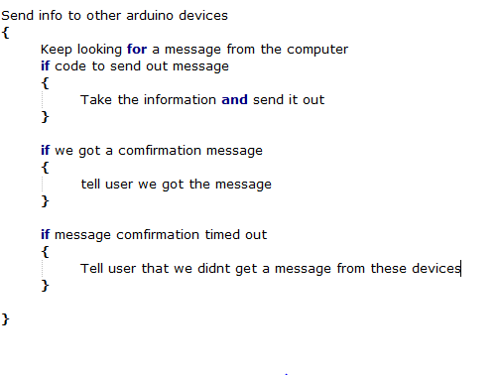

Device Program

*GPS communicator and translator*

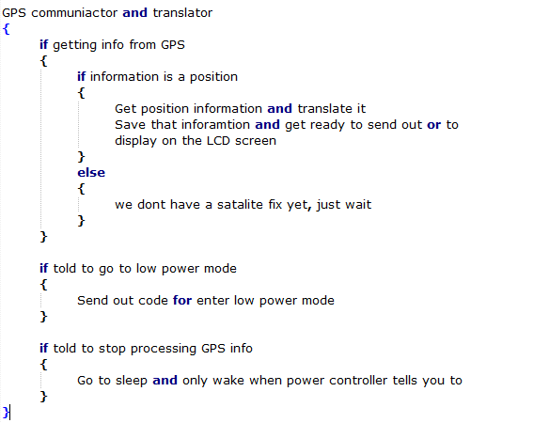

*Information passing protocol*

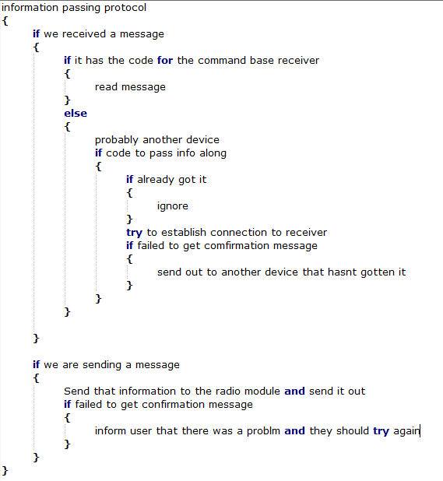

*Power consumption manager*

